CURRENT NEEDS LIST 2025
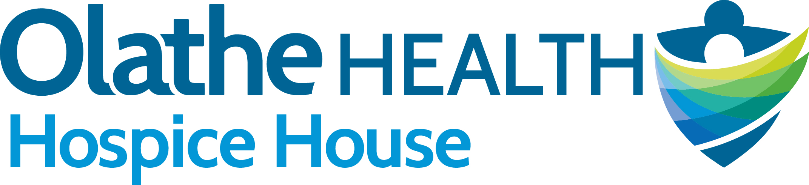
Items Are in Order of Greatest Need
Paper Products: dinner plates, dessert plates, bowls, napkins, paper towels (no toilet paper please)

Individually packaged snack items – peanut butter cracker packs, cheese cracker packs, trail mix, granola bars, pretzels, etc. Also individually wrapped chocolates, mints, and candy. No unpopped popcorn please.
Plastic cutlery – forks, spoons, knives

Bear Creek Soup Mix - Potato, Chicken Noodle, Wild Rice, Minestrone, Broccoli Cheddar, Chili
(Can be found at Hy-Vee and Wal-Mart)
Slow Cooker Liners

Cascade Platinum Dishwasher Pods

Laundry detergent pods - any brand

Gallon size Ziploc bags with slide or zip lock closure (clear only)
Quart size Ziploc bags with slide or zip lock closure (clear only)
Sandwich size Ziploc bags with slide or zip lock closure (clear only)

Styrofoam cups – 8 oz – with lids
Styrofoam cups – 16 oz – with lids

Bottled water - unflavored, any brand

Air Freshener Sprays – Febreze, Glade, etc.

Single serving packets of instant oatmeal, plain and/or any flavor

Single serving packets of hot chocolate mix, any flavor

Single serving packets of bottled water flavoring, any flavor

Aluminum foil

Hair combs - various sizes
Travel size toiletries: shampoo, conditioner, toothpaste, soap, body wash, anti-perspirant, body lotion

Fleece fabric - NEW fleece only, 1 ½ yards in length, any width, colors and patterns suitable for adult males or females

Poly-Fil polyester fiber fill for stuffing pillows – NEW fiber fill only - 32 oz bag or larger

*To receive a tax receipt for your donation, please complete the attached In-Kind Donation form.

