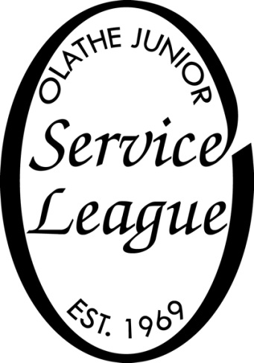
Olathe Junior Service League
Scholarship Application

Olathe Junior Service League is a women’s volunteer service organization which has been involved in the Olathe community for over fifty years. Because of our commitment to volunteerism, community service is the most important role in determining our scholarship winners.
OJSL provides 3 scholarship Olathe High school seniors including KSD. Recipients are determined based mainly on their community service involvement. This one-time $1000.00 scholarship money will be paid directly to the school upon receiving enrollment documentation from the student.

Required Elements for this Application:
Completed Application
Essay
Copy of your most recent transcript
3 letters of reference
Applicants must fully complete this application and submit it to their counselor’s office by March 1. The scholarship will be presented at Senior Awards Night.

EVALUATION PROCEDURE
A selection committee will review and evaluate all properly completed applications. A rating sheet will be used as part of the evaluation process. Each application must meet all eligibility requirements.

Olathe Junior Service league Scholarship
Personal Information
Name:
Address:
City, State, Zip:
Date of Birth:
Home Phone: Email:
Parents or Guardian:

Educational Experience:
Name of High School(s) attended:
Unweighted GPA: Weighted GPA:
Extracurricular School Activities: (in order of importance to you)
1. 4.
2. 5.
3. 6.
List distinctions, honors, and awards you have received at school and describe how you earned them.

Experiences outside of School:
Activities you are involved in:
(Type of activity, number of years, how you were involved, awards or honors received)

Work Experience:
Type of work Name of Employer Dates

Community Service:
List any community service/volunteer activities that you have participated in during your high school years. Please add additional pages if needed.
Activity &  Sponsoring Organization | Dates | Service Hours | Description of your Participation

Essay
One page, double spaced (attached with the application)
Please describe your involvement in community and service and how it has impacted you.

Accompany Information
Three sealed confidential references.
One must be a high school teacher
One by be a community service leader you have worked with
One by another non-family source

Official copy of your high school transcript

_________________________________________________ _____________________
Signature of Applicant Date

_________________________________________________ _____________________
Signature of parent or guardian Date
Parents’ Confirmation: I have reviewed this form, and this application is being made with my approval.
Incomplete applications will NOT be considered.
Scholarships are to be utilized for tuition and or books, Payment will be made directly to the school upon confirmation of enrollment. Payment will not be directly to the recipient.
Mail all information to:
OJSL
PO BOX 721
OLATHE, KS 66051

